Weekly Research Report Studio 5

Student name :Zihan Liu

Report date : 22/2/2024

What did you do this week?

**I have finished the design of the main page by using hand draw and Figma web design tool 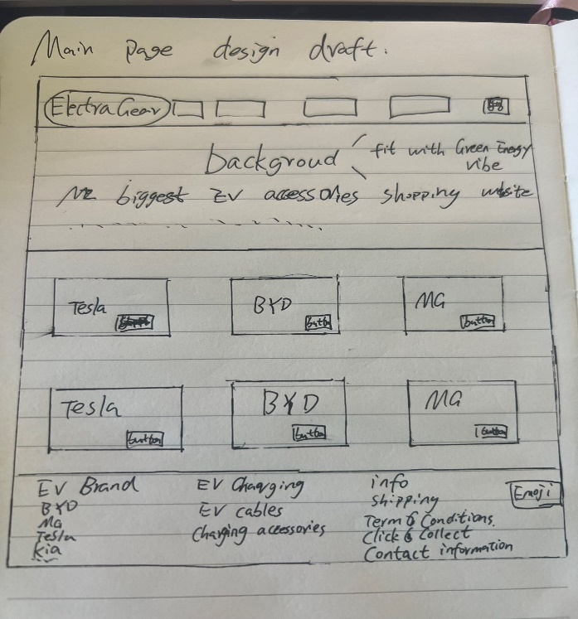**

**Keep working on the requirement analysis report.   
  
  
Working environment has been fully set up and tested with java code**

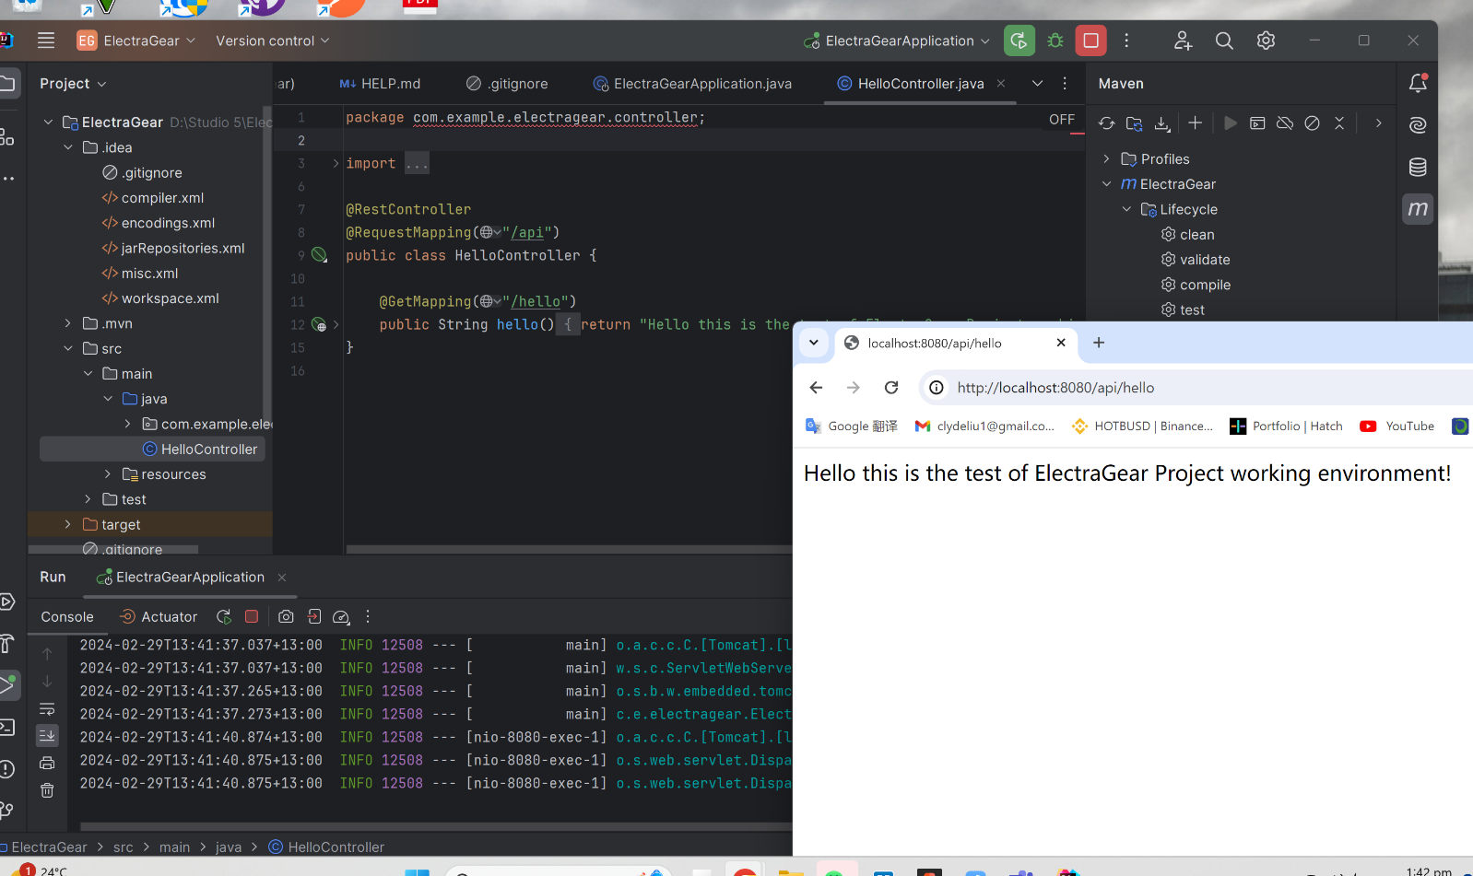

What are you planning to do next week?

*Design other pages   
Keep writing the requirement analysis report*

*Keep updating the Trello dashboard, give more tasks.*

*Comparing other similar websites to gain some business and design inspires.*

Do you need help with anything?

Any suggestions for this stage?  
is there any other useful or helpful tasks for me to do next week?

Thank you